Roughly Find the Positions for the Cargo Containers

1 Steps of drawing the map for analysis

We use image analysis to roughly find the positions for the cargo containers. Followings are some calculations for drawing the image:

The furthest distance that the Type B drone can carry medicines to hospital and fly back (XB, max, round-trip):

1111111

The furthest distance that the Type D drone can carry medicines to hospital and fly back (XD, max, round-trip):

2222222

The furthest distance that the Type B drone can fly from one cargo container to another cargo container with medicines and cargo bay (XB, max, single-trip):

3333333

We use MATLAB to plot the following image.

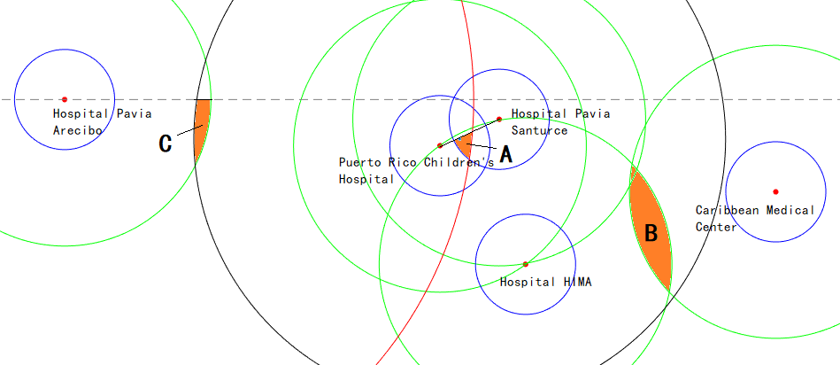

The five red dots represent the five hospitals.

The five blue circles (radius = XD, max, round-trip, with the center at the five red dots) means if the cargo container is in the blue circles, Type D drones can deliver medicines to the corresponding hospital.

The five green circles (radius = XB, max, round-trip, with the center at the five red dots) means if the cargo container is in the green circles, Type B drones can deliver medicines to the corresponding hospital.

The red circle (radius = XB, max, round-trip + XB, max, single-trip, with the center at the most left red dot) means the furthest positions Type B drones can fly to (with the precondition that Type B drones can deliver medicines to the most left hospital). If we set another cargo container in the red circle, Type B drones can deliver medicines between these two containers.

The dashed line is the approximate coastline, and the line between the middle two red dots represents the coastline there. We cannot place cargo containers above them.

(\* We will give the information for the black circle and Area A, B, C after some analysis.)

2 The Aspects of a Good Locations for Cargo Containers

The number of hospitals which can be covered by the deliver ability of two types of drones.

Whether can transfer the medicines by drones between two cargo containers or not. This ability allows we load medicines in other containers and transfer to the one needs them. It will promote the maximum of the days which medicines can keep supplying.

3 Results of the Rough Positions for the Three Cargo Containers

We choose Area A (which is shown in the picture) to place the Cargo Container A, because a cargo container there

can deliver medicines to the middle two hospitals by Type B and D drones;

can deliver medicines to the bottom hospital by Type B drones;

remain the possibility to transfer medicines to other two cargo containers (one in the left and one in the right).

We choose Area B (which is shown in the picture) to place the Cargo Container B, because a cargo container there

can deliver medicines to the bottom hospital and the right one by Type B drones;

can transfer medicines to Cargo Container A which is in the Area A.

We draw the black circle (radius = XB, max, single-trip, with the center at the Area A), which shows the furthest positions where Type B drones can fly (from Area A) to.

Thus, we choose Area C (which is shown in the picture) to place the Cargo Container C, because a cargo container there

can deliver medicines to the left hospital by Type B drones;

can transfer medicines to Cargo Container A which is in the Area A.